**Distance Vector Routing Algorithm-**

 Distance Vector Routing is a dynamic routing algorithm.

It works in the following steps-

**Step-01:**

Each router prepares its routing table. By their local knowledge. each router knows about-

* All the routers present in the network
* Distance to its neighboring routers

**Step-02:**

* Each router exchanges its distance vector with its neighboring routers.
* Each router prepares a new routing table using the distance vectors it has obtained from its neighbors.
* This step is repeated for (n-2) times if there are n routers in the network.
* After this, routing tables converge become stable.

**Distance Vector Routing Example-**

Consider-

* There is a network consisting of 4 routers.
* The weights are mentioned on the edges.
* Weights could be distances or costs or delays.

Ezoic

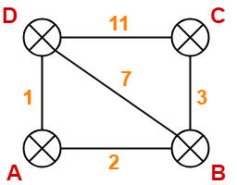

**Step-01:**

Each router prepares its routing table using its local knowledge.

Routing table prepared by each router is shown below-

**At Router A-**

|  |  |  |
| --- | --- | --- |
| **Destination** | **Distance** | **Next Hop** |
| A | 0 | A |
| B | 2 | B |
| C | ∞ | – |
| D | 1 | D |

**At Router B-**

|  |  |  |
| --- | --- | --- |
| **Destination** | **Distance** | **Next Hop** |
| A | 2 | A |
| B | 0 | B |
| C | 3 | C |
| D | 7 | D |

**At Router C-**

|  |  |  |
| --- | --- | --- |
| **Destination** | **Distance** | **Next Hop** |
| A | ∞ | – |
| B | 3 | B |
| C | 0 | C |
| D | 11 | D |

**At Router D-**

|  |  |  |
| --- | --- | --- |
| **Destination** | **Distance** | **Next Hop** |
| A | 1 | A |
| B | 7 | B |
| C | 11 | C |
| D | 0 | D |

**Step-02:**

* Each router exchanges its distance vector obtained in Step-01 with its neighbors.
* After exchanging the distance vectors, each router prepares a new routing table.

This is shown below-

**At Router A-**

* Router A receives distance vectors from its neighbors B and D.
* Router A prepares a new routing table as-

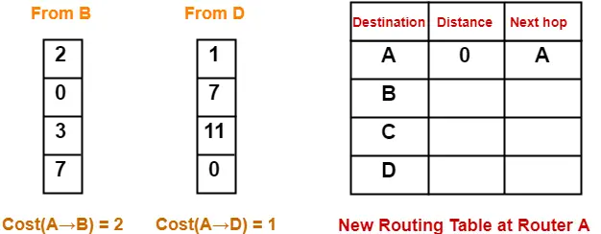

* Cost of reaching destination B from router A = min { 2+0 , 1+7 } = 2 via B.
* Cost of reaching destination C from router A = min { 2+3 , 1+11 } = 5 via B.
* Cost of reaching destination D from router A = min { 2+7 , 1+0 } = 1 via D.

|  |
| --- |
| **Explanation For Destination B**     * Router A can reach the destination router B via its neighbor B or neighbor D. * It chooses the path which gives the minimum cost. * Cost of reaching router B from router A via neighbor B = Cost (A→B) + Cost (B→B)= **2 + 0** = 2 * Cost of reaching router B from router A via neighbor D = Cost (A→D) + Cost (D→B) = **1 + 7** = 8 * Since the cost is minimum via neighbor B, so router A chooses the path via B. * It creates an entry (2, B) for destination B in its new routing table. * Similarly, we calculate the shortest path distance to each destination router at every router. |

Thus, the new routing table at router A is-

|  |  |  |
| --- | --- | --- |
| **Destination** | **Distance** | **Next Hop** |
| A | 0 | A |
| B | 2 | B |
| C | 5 | B |
| D | 1 | D |

**At Router B-**

* Router B receives distance vectors from its neighbors A, C and D.
* Router B prepares a new routing table as-

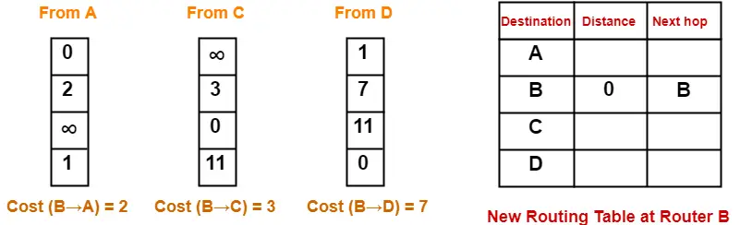

* Cost of reaching destination A from router B = min { 2+0 , 3+∞ , 7+1 } = 2 via A.
* Cost of reaching destination C from router B = min { 2+∞ , 3+0 , 7+11 } = 3 via C.
* Cost of reaching destination D from router B = min { 2+1 , 3+11 , 7+0 } = 3 via A.

Ezoic

Thus, the new routing table at router B is-

|  |  |  |
| --- | --- | --- |
| **Destination** | **Distance** | **Next Hop** |
| A | 2 | A |
| B | 0 | B |
| C | 3 | C |
| D | 3 | A |

**At Router C-**

* Router C receives distance vectors from its neighbors B and D.
* Router C prepares a new routing table as-

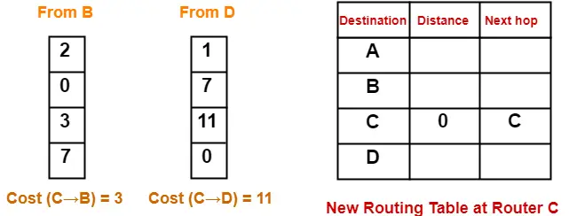

* Cost of reaching destination A from router C = min { 3+2 , 11+1 } = 5 via B.
* Cost of reaching destination B from router C = min { 3+0 , 11+7 } = 3 via B.
* Cost of reaching destination D from router C = min { 3+7 , 11+0 } = 10 via B.

Thus, the new routing table at router C is-

|  |  |  |
| --- | --- | --- |
| **Destination** | **Distance** | **Next Hop** |
| A | 5 | B |
| B | 3 | B |
| C | 0 | C |
| D | 10 | B |

**At Router D-**

* Router D receives distance vectors from its neighbors A, B and C.
* Router D prepares a new routing table as-

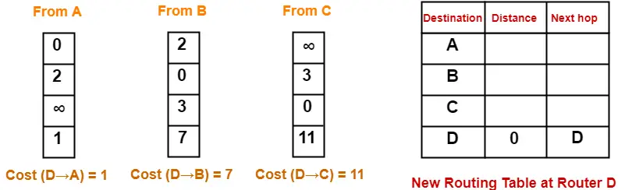

* Cost of reaching destination A from router D = min { 1+0 , 7+2 , 11+∞ } = 1 via A.
* Cost of reaching destination B from router D = min { 1+2 , 7+0 , 11+3 } = 3 via A.
* Cost of reaching destination C from router D = min { 1+∞ , 7+3 , 11+0 }= 10 via B.

Thus, the new routing table at router D is-

|  |  |  |
| --- | --- | --- |
| **Destination** | **Distance** | **Next Hop** |
| A | 1 | A |
| B | 3 | A |
| C | 10 | B |
| D | 0 | D |

**Step-03:**

* Each router exchanges its distance vector obtained in Step-02 with its neighboring routers.
* After exchanging the distance vectors, each router prepares a new routing table.

This is shown below-

**At Router A-**

* Router A receives distance vectors from its neighbors B and D.
* Router A prepares a new routing table as-

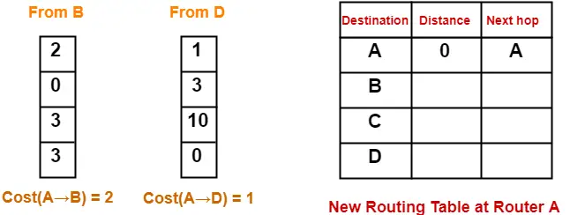

* Cost of reaching destination B from router A = min { 2+0 , 1+3 } = 2 via B.
* Cost of reaching destination C from router A = min { 2+3 , 1+10 } = 5 via B.
* Cost of reaching destination D from router A = min { 2+3 , 1+0 } = 1 via D.

Thus, the new routing table at router A is-

|  |  |  |
| --- | --- | --- |
| **Destination** | **Distance** | **Next Hop** |
| A | 0 | A |
| B | 2 | B |
| C | 5 | B |
| D | 1 | D |

**At Router B-**

* Router B receives distance vectors from its neighbors A, C and D.
* Router B prepares a new routing table as-

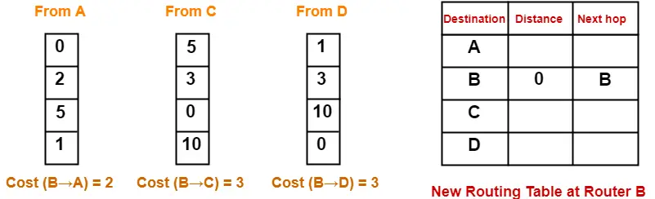

* Cost of reaching destination A from router B = min { 2+0 , 3+5 , 3+1 } = 2 via A.
* Cost of reaching destination C from router B = min { 2+5 , 3+0 , 3+10 } = 3 via C.
* Cost of reaching destination D from router B = min { 2+1 , 3+10 , 3+0 } = 3 via A.

Thus, the new routing table at router B is-

|  |  |  |
| --- | --- | --- |
| **Destination** | **Distance** | **Next Hop** |
| A | 2 | A |
| B | 0 | B |
| C | 3 | C |
| D | 3 | A |

**At Router C-**

* Router C receives distance vectors from its neighbors B and D.
* Router C prepares a new routing table as-

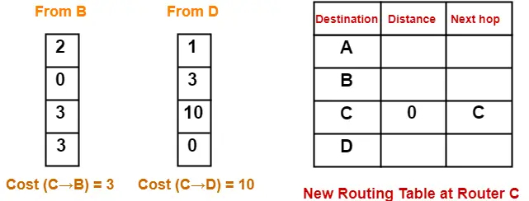

* Cost of reaching destination A from router C = min { 3+2 , 10+1 } = 5 via B.
* Cost of reaching destination B from router C = min { 3+0 , 10+3 } = 3 via B.
* Cost of reaching destination D from router C = min { 3+3 , 10+0 } = 6 via B.

Thus, the new routing table at router C is-

|  |  |  |
| --- | --- | --- |
| **Destination** | **Distance** | **Next Hop** |
| A | 5 | B |
| B | 3 | B |
| C | 0 | C |
| D | 6 | B |

**At Router D-**

* Router D receives distance vectors from its neighbors A, B and C.
* Router D prepares a new routing table as-

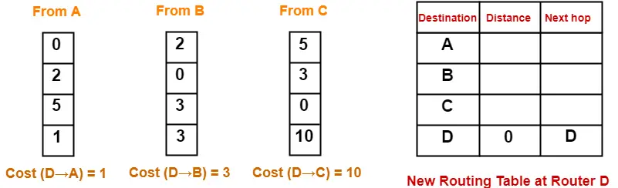

* Cost of reaching destination A from router D = min { 1+0 , 3+2 , 10+5 } = 1 via A.
* Cost of reaching destination B from router D = min { 1+2 , 3+0 , 10+3 } = 3 via A.
* Cost of reaching destination C from router D = min { 1+5 , 3+3 , 10+0 } = 6 via A.

Thus, the new routing table at router D is-

|  |  |  |
| --- | --- | --- |
| **Destination** | **Distance** | **Next Hop** |
| A | 1 | A |
| B | 3 | A |
| C | 6 | A |
| D | 0 | D |

These will be the final routing tables at each router.

**Identifying Unused Links-**

After routing tables converge (becomes stable),

* Some of the links connecting the routers may never be used.
* In the above example, we can identify the unused links as-

We have-

* The value of next hop in the final routing table of router A suggests that only edges AB and AD are used.
* The value of next hop in the final routing table of router B suggests that only edges BA and BC are used.
* The value of next hop in the final routing table of router C suggests that only edge CB is used.
* The value of next hop in the final routing table of router D suggests that only edge DA is used.

Thus, edges  BD and CD are never used.

**Important Notes-**

**Note-01:**

In Distance Vector Routing,

Ezoic

* Only distance vectors are exchanged.
* “Next hop”values are not exchanged.
* This is because it results in exchanging the large amount of data which consumes more bandwidth.

**Note-02:**

While preparing a new routing table-

* A router takes into consideration only the distance vectors it has obtained from its neighboring routers.
* It does not take into consideration its old routing table.

**Note-03:**

The algorithm is called so because-

* It involves exchanging of distance vectors between the routers.
* Distance vector is nothing but an array of distances.

**Note-04:**

* The algorithm keeps on repeating periodically and never stops.
* This is to update the shortest path in case any link goes down or topology changes.

**Note-05:**

* Routing tables are prepared total (n-1) times if there are n routers in the given network.
* This is because shortest path between any 2 nodes contains at most n-1 edges if there are n nodes in the graph.

**Note-06:**

* Distance Vector Routing suffers from count to infinity problem.
* Distance Vector Routing uses UDP at transport layer.